Lab 1: Implementation of an Array
Exercise 1: Delivery Trucks
Imagine you are working as a Computer Scientist for a shipping company that manages a
fleet of delivery trucks. Each truck has a unique ID, and these IDs are stored in an array to
monitor the fleet. Due to regular updates in the fleet, you need to perform several operations
such as inserting new trucks, removing old ones, searching for specific truck IDs, and
traversing the list to display the fleet status. Following list represent the truck IDS:
1005 1023 1030 1044 1056 1067 1078 1001 1129 1115 1180
Write a program in C++ and perform following task:
a. Insert a new truck ID 1011 at position 5
b. Traverse the array.
c. Delete a truck ID located at position 9
CODE
// saba shahid
//cs 3-A
// 02-134241-048

#include <iostream>
using namespace std;

int main() {
// array initialize karein ge
int trucksID[12] = { 1005, 1023, 1030, 1044, 1056, 1067, 1078, 1001, 1129, 1115, 1180 };
// Initializing number of original trucks
int size = 11;

// a
// Inserting new truck at position 5
int position = 5, newID = 1011;

// Shifting terucks in the array
for (int i = size; i > position; i--) {
trucksID[i] = trucksID[i - 1];
}
//inserting value at 5
trucksID[position] = newID;
size++;

// b
//Traversinggg the array
//also gonna display the array
cout << "array after insertion:"<<endl;
for (int i = 0; i < size; i++) {
cout << trucksID[i] << " ";
}
cout << endl;

// c
// Deleting truck ID at position 9
int deletePosition = 9;
for (int i = deletePosition; i < size - 1; i++) {
trucksID[i] = trucksID[i + 1];
}
size--;

// Displaying the array elemenets after delection is done
cout << "array after deletion:"<<endl;
for (int i = 0; i < size; i++) {
cout << trucksID[i] << " ";
}
cout << endl;

}
OUTPUT
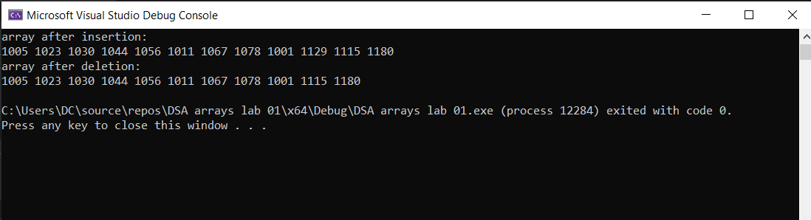
Exercise 2: Student Birth Record
At SBCD School, the administration maintains detailed records for all students, including
their birth years. As part of this record-keeping process, they store the birth year of each
student in an array. You have been assigned the task of writing a program to assist with
this process for a class of 20 students. Using the stored birth years, complete the
following:
a. Identify and print the position of the youngest student in the class.
b. Identify and print the position of the oldest student in the class.
c. Count and display how many students are exactly 20 years old (assuming the
current year is 2024).
d. Determine and print the number of students who have the same birth year.
CODE
// saba shahid
//cs 3-A
// 02-134241-048

#include <iostream>
using namespace std;

int main() {
// Initializing the array
int birthYears[20] = { 2005, 2006, 2004, 2003, 2006, 2005, 2002, 2003, 2004, 2006,2003, 2005, 2004, 2002, 2005, 2006, 2004, 2003, 2002, 2005 };

//needed indexes
int youngestIndex = 0;
int oldestIndex = 0;
int currentYear = 2024;
int count20YearsOld = 0;

// Find min and max birth years
int minYear = birthYears[0];
int maxYear = birthYears[0];

for (int i = 1; i < 20; i++) {
if (birthYears[i] > maxYear) maxYear = birthYears[i];
if (birthYears[i] < minYear) minYear = birthYears[i];
}

// Size of the count array
const int RANGE = 11;

// Initialize karein ge count array with 0
int birthYearCount[RANGE] = { 0 };

// Finding the youngest, oldest student
//also finding how many times did they occured
for (int i = 0; i < 20; i++) {
if (birthYears[i] > birthYears[youngestIndex]) {
youngestIndex = i;
}
if (birthYears[i] < birthYears[oldestIndex]) {
oldestIndex = i;
}
if (currentYear - birthYears[i] == 20) {
count20YearsOld++;
}

// count krne ke liye (how many times they occureed)
birthYearCount[birthYears[i] - minYear]++;
}

// ResUlt displayingg
cout << "position of youngest student:" << youngestIndex << endl;
cout << "position of oldest student:" << oldestIndex << endl;
cout << "number of students exactly 20 years old: " << count20YearsOld << endl;

// Display the count of students with the same birth year
cout << "number of students with the same birth year:" << endl;
for (int i = 0; i < RANGE; i++) {
if (birthYearCount[i] > 0) {
cout << "year " << (i + minYear) << ": " << birthYearCount[i] << " students" << endl;
}
}
}
OUTPUT
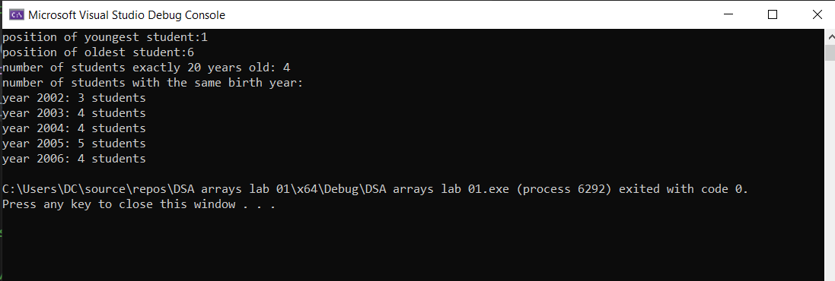
Exercise 3: Fitness tracking app
You are developing a fitness tracking system that records the number of minutes users
exercise daily. These values are stored in an array, representing the daily exercise minutes
for 10 different users over a week. The fitness app needs to perform various analyses on
the exercise data given as follows to provide insights to users and suggest improvements.
12 8 17 25 5 19 6 4 21 3
Write a program in C++ and perform following task:
a. Find All Pairs of Users Whose Exercise Minutes Sum to 25.
b. Count even and odd exercise minutes to create custom workout groups
c. Display maximum and minimum exercise time taken by users
d. Calculate average exercise minutes
CODE
// saba shahid
//cs 3-A
// 02-134241-048

#include <iostream>
using namespace std;

int main() {
// ARRAY BANAE GE FOR VALUES
int exerciseMinutes[10] = { 12, 8, 17, 25, 5, 19, 6, 4, 21, 3 };

//a
// findng all users whos ex time sum to 25 mins
cout << "pairs of users whose time mins sum to 25 mins:" << endl;
for (int i = 0; i < 10; i++) {
for (int j = i + 1; j < 10; j++) {
if (exerciseMinutes[i] + exerciseMinutes[j] == 25) {
cout << "user " << i + 1 << " (" << exerciseMinutes[i] << ") + user "
<< j + 1 << " (" << exerciseMinutes[j] << ")" << endl;
}
}
}

//b
// counting the even and odd ex mins
int evenCount = 0, oddCount = 0;
for (int i = 0; i < 10; i++) {
if (exerciseMinutes[i] % 2 == 0)
evenCount++;
else
oddCount++;
}
cout << "even exercise mins count:" << evenCount << endl;
cout << "odd exercise mins count:" << oddCount << endl;

//c
// we will find max and min ex time

int maxMinutes = exerciseMinutes[0];
int minMinutes = exerciseMinutes[0];

for (int i = 1; i < 10; i++) {
if (exerciseMinutes[i] > maxMinutes)
maxMinutes = exerciseMinutes[i];
if (exerciseMinutes[i] < minMinutes)
minMinutes = exerciseMinutes[i];
}

cout << "max exercise time:" << maxMinutes << " mins" << endl;
cout << "min exercise time:" << minMinutes << " mins" << endl;

// Task d
//Calculating the average ex mins and we are doneee :p
int sum = 0;
for (int i = 0; i < 10; i++) {
sum += exerciseMinutes[i];
}
double average = static_cast<double>(sum) / 10;
cout << "average exercise mins:" << average << " minutes" << endl;
}
OUTPUT
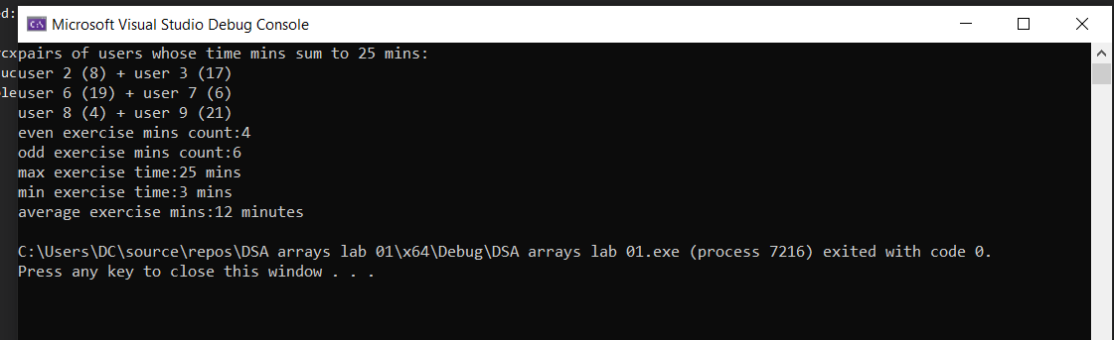
Exercise 4: Library books record
XYZ Library maintains a digital record of the books in their collection. Each book's title is
stored in a list to keep track of their current order. The library recently decided to reverse
the order of the books in their records to reflect the latest arrangement on their website.
Write a C++ program and perform following task:
a. Insert a book in the list
b. Calculate total number of books the collection.
c. Reverse the order of the books.
CODE
//saba shahid
// 02-134241-048
// CS 3-A
#include <iostream>
using namespace std;

int main() {

// MAX KITNI BOOKS RAKH SKTE HAIN
const int MAX_BOOKS = 10;

// array store krne ke liye
char books[MAX_BOOKS][100];
int currentBookCount = 0;

for (int i = 0; i < MAX_BOOKS; i++) {
// a
// inserting a book in the list
char newBook[100];

cout << "enter the title of the book to insert: ";
// will use getline to ignore spaces in the book title
cin.getline(newBook, 100);

// loop laga rae hain cuz mwe don wanna repeat
if (currentBookCount < MAX_BOOKS) {
// copying the title into the books wala array
int j = 0;
while (newBook[j] != '\0' && j < 100) { // Stop copying at null terminator
books[currentBookCount][j] = newBook[j];
j++;
}
books[currentBookCount][j] = '\0'; // Ensure null termination

currentBookCount++;
cout << "book inserted successfully :)" << endl;
}
else {
cout << "the library array is full :(" << endl;
}
}

// b
// calculating total number of books in the array
cout << "total number of books in the collection: " << currentBookCount << endl;

// c
// Reversing the order of the books
cout << "books in reverse order:" << endl;
for (int i = currentBookCount - 1; i >= 0; i--) {
cout << books[i] << endl;
}
}

OUTPUT
